Sum-Meet
Use Case Specification

Submitted to:

Asst. Prof. Ma. Rowena C. Solamo
Faculty Member
Department of Computer Science
College of Engineering
University of the Philippines, Diliman

Submitted by:
Batula, Bryce Spencer
Bayuga, Michael John
Yap, John Theodore

In partial fulfillment of academic requirements
for the course
CS 191 Software Engineering I
of the
1st Semester, AY 2015-2016
Unique Reference:
The documents are stored in https://github.com/trackertech568/CS191-Batula-Bayuga-Yap.
[File Reference in GitHub, preferably link.]

Document Purpose:
To show the flow of events of a use-case from its diagram.

Target Audience:
Meeting organizers.

Revision Control

History Revision:
Revision Date | Person Responsible | Version  Number | Modification
09/18/15 | Batula, Bryce  Bayuga, Michael  Yap, John Theodore | 1.0 | Initial Document; Version number should match the one found in the footer.

Use-Case Name: 2.0 Attendance

Description: Attendee will confirm attendance to the meeting prior to the actual meeting. Verification of attendance will be done in the actual meeting.

Preconditions: NONE

Flow of Events:
Scenario Name | Description
Scenario 1 (Basic Flow)  Attendee confirms going to the meeting. | 1. System will send a notification to the attendee for a meeting  2. Attendee will confirm going to the meeting.  3. System will update attendees list to include the attendee who confirmed going to the meeting.
Scenario 2  Attendee does not confirm going to the meeting | 1. System will send a notification to the attendee for a meeting  2. Attendee does not confirm going to the meeting.  3. System will not include attendee in the attendees list

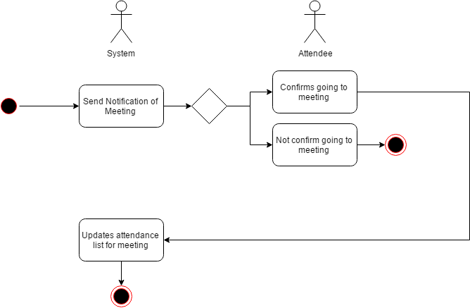
Activity Diagram of the Flow of Events:

Postcondition: NONE

Relationships: NONE

Special Requirements:
NONE

Use-Case Name: 2.1 Confirmation of Attending

Description: Attendee will verify attendance to the meeting he/she has confirmed will go to.

Preconditions: Confirmed attendance in 2.0(Attendance)

Flow of Events:
Scenario Name | Description
Scenario 1 (Basic Flow)  Attendee will confirm attendance via signature | 1. Attendee signs to verify attendance.  2. System should update the attendance sheet.
Scenario 2  Attendee will confirm attendance via photo | 1. Attendee takes a photo to verify attendance.  2. System should update the attendance sheet.
Scenario 3  Attendee does not go to the meeting | 1. Attendee’s absence is reflected on the system’s attendance sheet record.

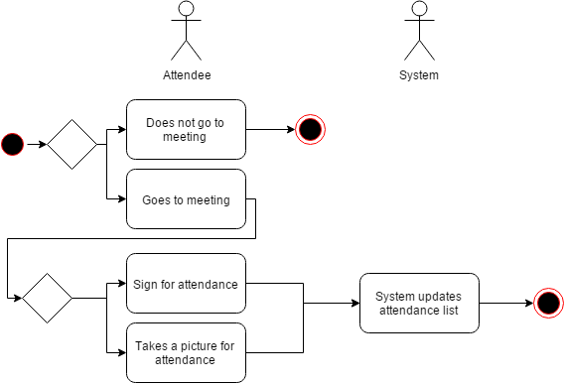

Activity Diagram of the Flow of Events:

Postcondition: NONE

Relationships: NONE

Special Requirements:
NONE

Use-Case Name: 2.2 Edit Answer

Description: Attendee will update his/her answer for the meeting. Either it is his/her first answer or not. The meeting organizer will be notified for the changes.

Preconditions: Attendee has answered the system notification about the meeting in 2.0 (Attendance)

Flow of Events:
Scenario Name | Description
Scenario 1 (Basic Flow)  Attendee will change from not confirmed to confirmed attendance | 1. Attendee changes his/her answer  2. System will update attendees list to include the attendee that confirmed.
Scenario 2  Attendee will change from confirmed attendance to not confirmed attendance. | 1. Attendee changes his/her answer  2. System will update attendees list to exclude the attendee that removed confirmation.

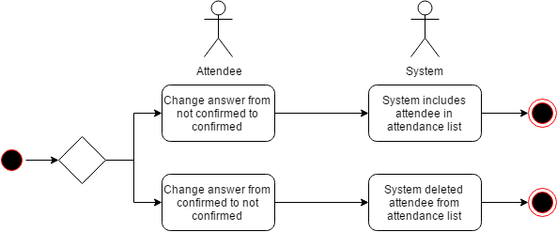

Activity Diagram of the Flow of Events:

Postcondition: NONE

Relationships: NONE

Special Requirements:
NONE

Use-Case Name: 2.3 Print Attendance

Description: Attendee requests a hard copy of the attendance sheet from the meeting organizer.

Preconditions: Attendee is present during the meeting 2.1 (Confirmation of Attending)

Flow of Events:
Scenario Name | Description
Scenario 1 (Basic Flow)  Attendee will ask for a copy of the attendance sheet | 1. Attendee requests for copy of the attendance sheet  2. Meeting Organizer prints hard copy of attendance sheet.  3. Attendee will receive the hard copy from meeting organizer

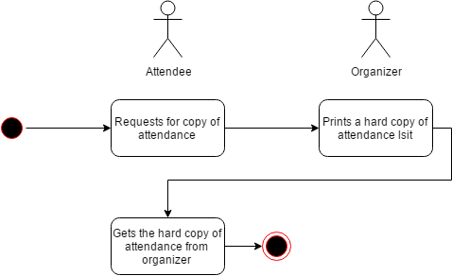

Activity Diagram of the Flow of Events:

Postcondition: NONE

Relationships: NONE

Special Requirements:
NONE

